Friends of Middle River -- VOLUNTEERS NEEDED
Saturday May 4, 2019 -- 10AM - 3PM

Volunteers are needed to staff the STREAM SAFARI event at RIVERFEST. This event allows youth to wade in the South River and help collect aquatic insects using seine and D-nets. The insects are exhibited onshore. | 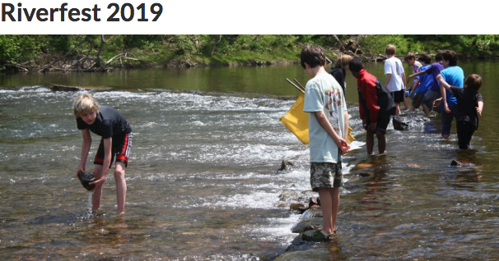

WHAT IS RIVERFEST?

This FREE annual event takes place river-side at Constitution Park in Waynesboro, VA. Activities include Reptile World shows, Stream Safari, presentations by the Wildlife Center of Virginia, Fish and Fun Rodeo, Farmer’s Market, canoe rides, kids arts & crafts, Stream electro-fishing with DGIF and is capped off by the … Great South River Duck Race!! Rain or Shine – No Pets Allowed
Riverfest reaches more than 2000 children and adults, and emphasizes our commitment and responsibility to the conservation of our natural resources.
The sponsors welcome environmentally-themed organizations and companies as exhibitors. Friends of Middle River will have a booth in the exhibit area.

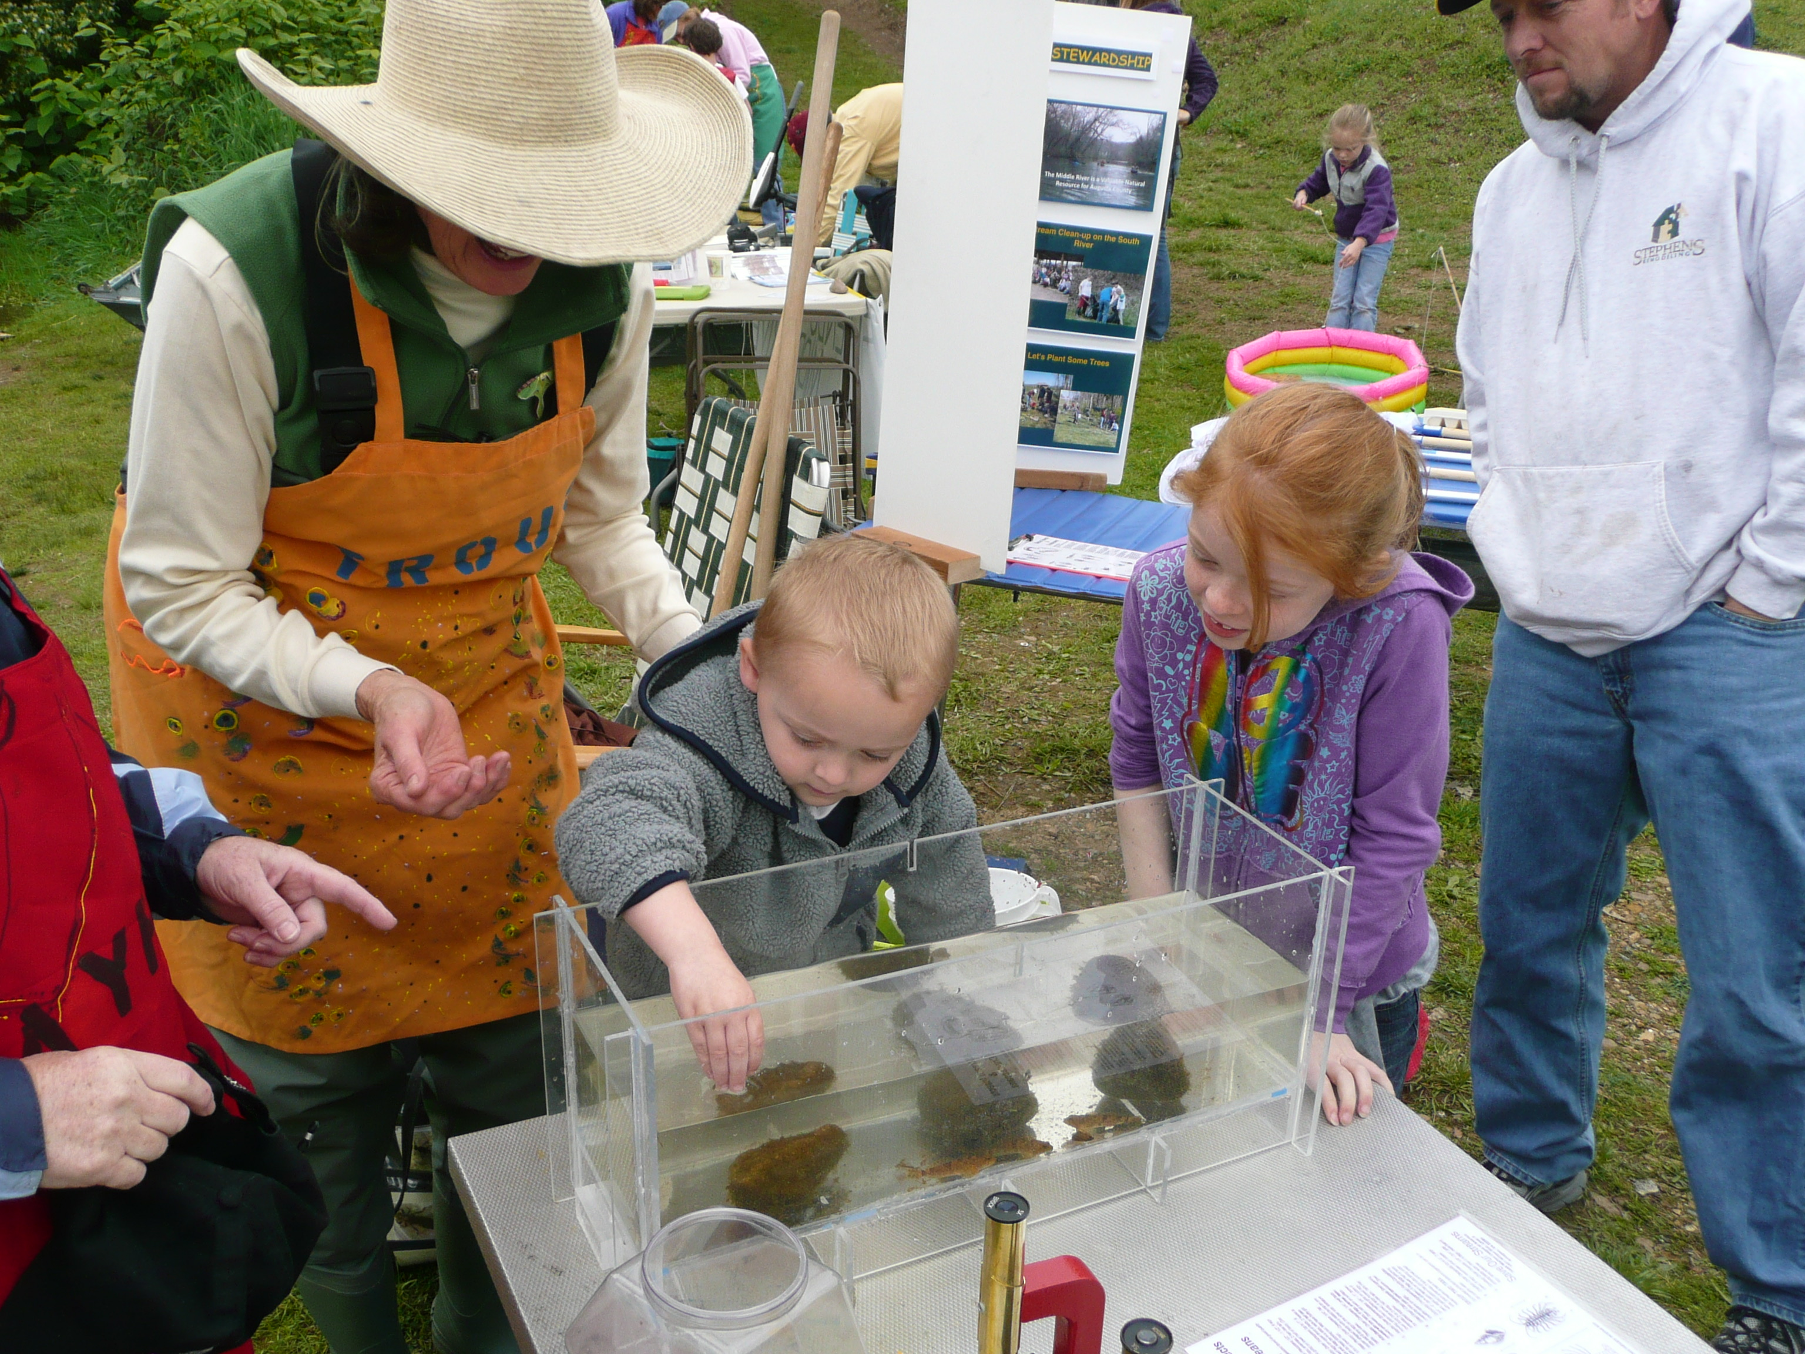 | 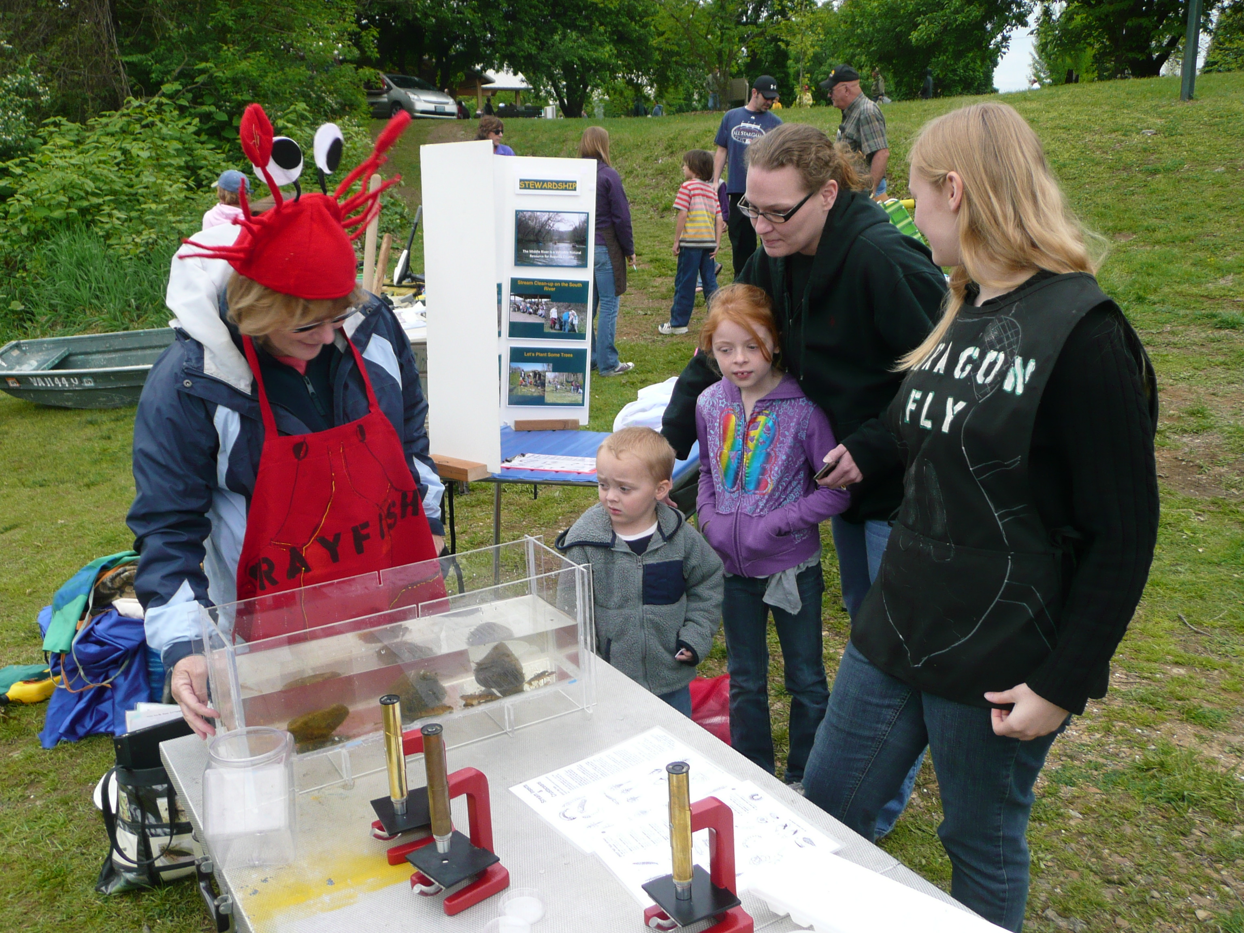 | 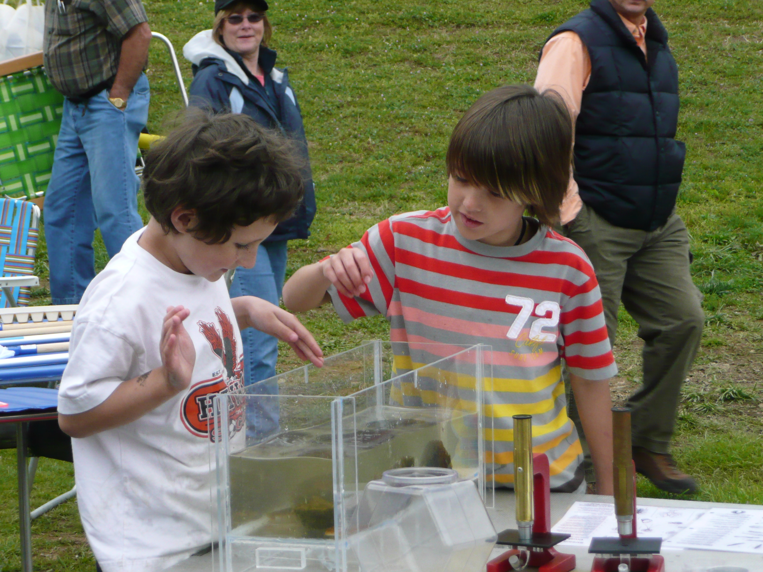

VOLUNTEERS FOR INSECT COLLECTION AND SAFETY MONITORS -- FOMR would also like to provide volunteers to help stream-side with the netting of aquatic insects, and for water safety monitors for youth collecting the insects. Volunteers should have boots or old shoes to walk in the water.

There will be two shifts: 10AM to 12:30 and 12:30 to 3:00PM. If you can help, please email schwalmie2@aol.org.

